

ROYAL MELBOURNE INSTITUTE OF TECHNOLOGY

**Bachelor:** *Information and Technology.*

**Project:** *On display navigation and notification.*

**Student:** *Jaime Salgado.*

**Class:** *COSC2196*

*Introduction to Information Technology*

**Student ID:** *S3788424*

Melbourne, 17 march 2019.

# Overview

The following objectives must be met for the project:

## Objective

* Generate a device that is capable of transmitting and displaying our navigation maps and notifications, while driving, without affecting the user, this.
* based on already pre-established maps, only connecting them with our own personalized app.

## Specific Objective

* Generate a functional device that is able to show us the navigational element fulfilling the objective of not interfering in the driving.
* Being able to achieve communication between the device and smartphones, this has to be displayed in a friendly way.
* Make a product that is functional and manages to enter the technology market.

Motivation for Project:

One of the problems when we handle and to locate the addresses is why we should check map books or our default directions app, but at the time we drive we cannot distract with our smartphone.

In 2010, 297 million mobile phones were sold worldwide and 41% of them used their own or minority operating systems. Android was only in 22.7% of the terminals, and iOS in 15.7%. BlackBerry, today almost disappeared, was still used in 14% of mobile phones. In 2017, close to 1.5 billion mobile phones were sold, and Android is used in 85.9% of all of them. Interestingly, iOS maintains the same market share as 7 years ago, 16%, but logically with many more phones sold, since in 2017 five smartphones were sold more than in 2010. (Pascual, 2018)

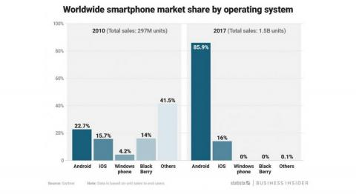

Starting from the previous statistics we must focus on two types of devices to create our app.

# Bibliography

Pascual, J. A. (2018, July 7). *Computer Hoy*. Retrieved from Camputer Now: https://computerhoy.com/reportajes/industria/android-vs-iphone-guerra-smartphones-cifras-271447

# Project Detail

This project is about creating a functional device that will benefit all users who use a smartphone (Android and iPhone O.S.) to locate the address while they are driving, without affecting or distracting their eyes on the road.

Given that most users are focused on two types of mobile operating systems; the project will be divided into stages. Since it involves creating the device (hardware), the internal software that will be used and the interface App between users and their smartphone.

In the current market, there are already some vehicles already installed in modern cars, but what happens with the cars of previous years.

There is also a phone holder, but these tend to force the user to show the complete information of the phone, which can cause distractions when driving on the road. They are also affected by heat and energy consumption since they tend to be connected by showing the screen.

Create the App and the program that will use the device, this should be with friendly GUI and easy to connect. that's why you should be develop software in Android, Raspberry and IOS. then you can place them in the google store and app store.

From this problematic it raises the idea of ​​the project:

# Overview

## Stage 1 Hardware:

Stage 1 will include the creation of a device (hardware) that will display the navigation elements and notifications while the user is driving. The user should communicate with an app installed on the client's smartphone, the device should be friendly, easy to use and without distracting elements.

In order to create a communication link between the device and the smartphone, it must be via wireless through the technology of the Bluetooth.

### Tools and Technologies:

1. Motherboard.

* Raspberry Pi Zero W.
* Cost: $15.19.

1. LCD display.

* 2.2-inch LCD Display Module w/ PL2303 Serial for Raspberry Pi.
* Cost: $10.40

1. Connector

* HDMI to LCD display.
* Cost: $1.70.

1. Input voltage

* USB Port for Cell Phone Car Charger 5V
* Cost: $3.20.

Note: The costs are bought for each element of the prototype and if you want to bulk up, the prices have to go down.

### Prototype:

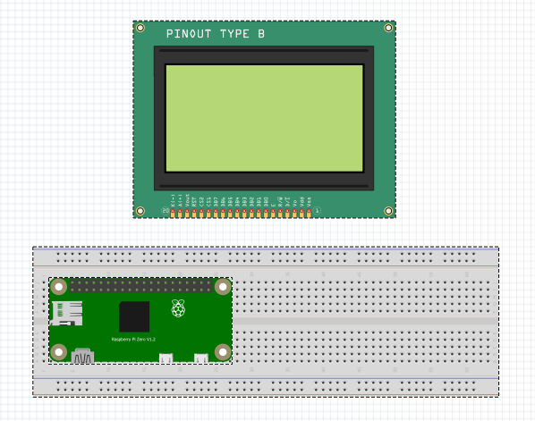

## Stage 2 Software Developed:

As a developer, you should learn different languages ​​and be able to design and program in Java and Swift, as well as know electronic, communication and data concepts. We must be able to design the prototype in 3D.

As well as having them connect with the Google APIs or the IOS maps.

Stage two will be the App program in 3 different types of platforms:

* Android
* Raspberry
* IOS

### Android App

For the Android develop app we should know how to program in Java, the software that will be used in Eclipse.

### IOS App

For the Android develop app we should know how to program in Swift, and the software is the Xcode, and have a MAC computer.

### Raspberry software

This software should be able to communicate via Bluetooth with our created app. to the Raspberry you can mount Linux distribution in this case is called Raspbian, and create a package with its own GUI. For the develop whit have to use Java.

At the end they should be uploaded to the Play Store and App Store.

Before creating the prototype and uploading the files, we can test them in a program called Proteus, without needing to give the electronic components or circuits.

## Stage 3 Prototype and Test:

Create the 3D prototype and then print in a 3D model that will host the device in its interior.

We must assemble and test all the components in a lapse of time, then collect data and analyze them and try to improve it before launching into the market our product.

## Stage 4 Outcome:

In this stage we must upload the app, sell the product and should be placed either in Ebay and Amazon, for this we must organize the logistics of distribution know the shipping cost. Previously we must cut the cost, how we will achieve it, start business with the raspberry manufacturers and buy in bulk.

Calculate the profit margin generated by the product. with the formula $$percentage gross = gross profit / total income x 100.$$

Plus, the amount of downloads that will be made in Android and Apple stores, in this project it is about avoiding advertising as part of profit, so we must to focus more on the sale of the product.